**Assignment Attachment**

* **DDL SCRIPT FILE TO CREATE THE TABLE**



* **INSERT SCRIPT FOR SAMPLE DUMP**





* **SQL SCRIPTS FOR INSERT/UPDATE/DELETE OPERATIONS IN DATABASE**



* **All files in the zip -** 

**Output Screenshots -**

* **BOOK_TABLE -**

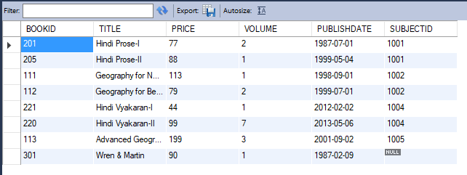

* **SUBJECT_TABLE -**

